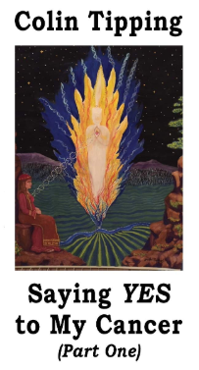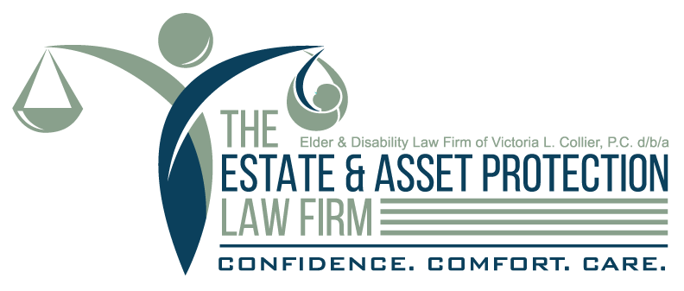

The Elder & Disability Law Firm of Victoria L. Collier, PC d/b/a The Estate & Asset Protection Law Firm has a mission to ensure people live and die with the best quality possible. The Founder, Victoria Collier, worked in a nursing home as a nurse’s aide, cared for her father when he died in hospice, and guides many families with loved ones who are dying.

Often the difference between a good death and a bad one is preparation and the willingness to communicate our desires and fears.

The Estate & Asset Protection Law Firm is hosting a very special, private event for clients and a select few professionals to attend to begin these conversations. You have been invited because of the relationship we have had with your company over the years.

Special guest, top selling author of *Radical Forgiveness*, Colin Tipping, and his death guide and companion are expected to be in attendance. Colin just published his latest book, Saying Yes to My Cancer, April 2019. Each attendee will receive a free copy.

We are limiting the group to 20 total people, and extending the invitation to only 5 professional organizations. Please RSVP as soon as possible to secure your spot.

This is not a support group or a networking event. It is an event where likeminded people who want to discuss our feelings, ask questions, and listen to others discuss death.

Wine, cake and other refreshments will be provided.

***RSVP at (404) 370-0696***

315 W Ponce de Leon Ave, Suite 600

Decatur, GA 30030

Discussions About Death

Hosts...

You’re Invited